Two Indian IM-norms in Budapest

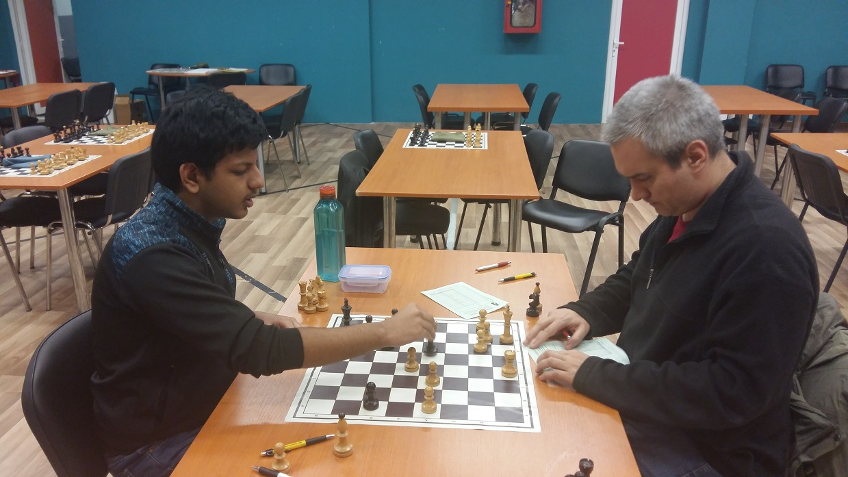

Om Kharola from India made his maiden IM-norm in the GM group!

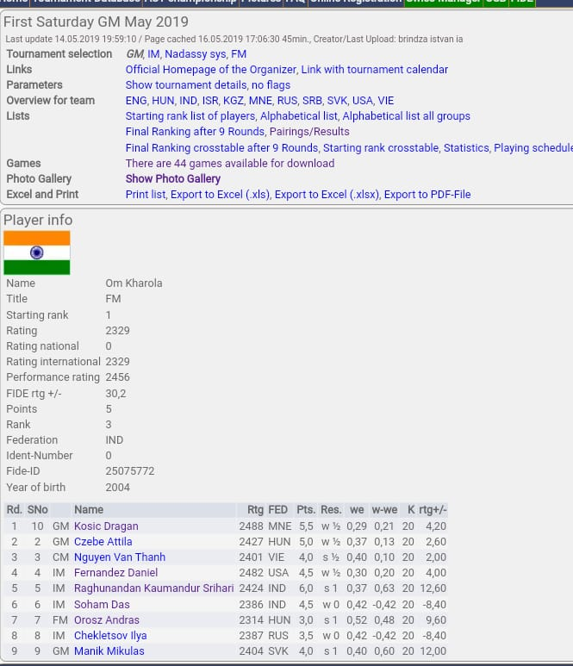

Om’s impressive performance at First Saturday GM May 2019!

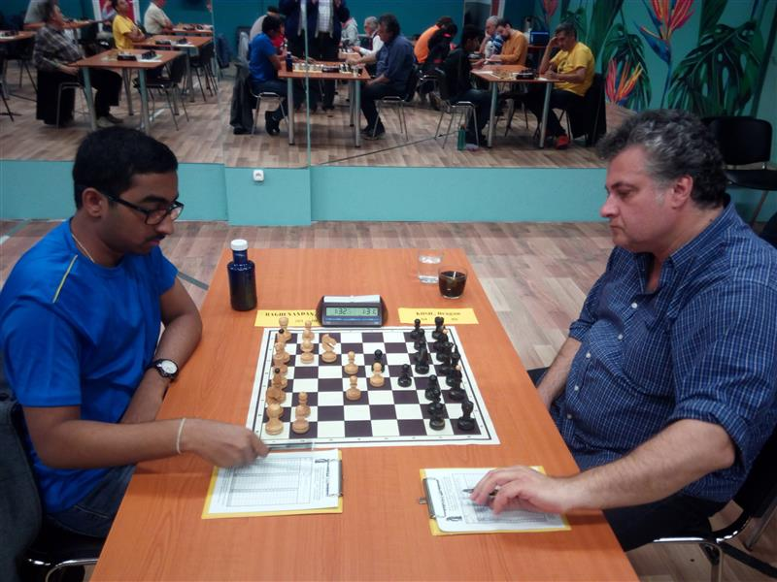

IM KS Raghunandan’s (IND) incredible 15th move win against an experienced Grandmaster Master brings him the Champion title of First Saturday GM tournament!

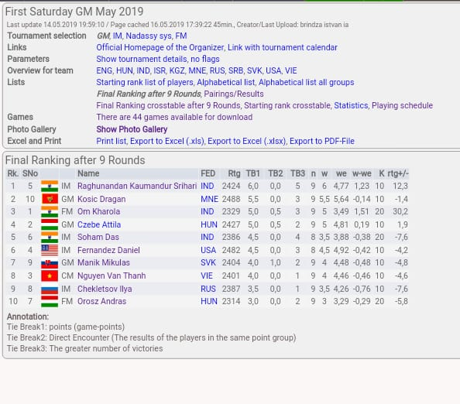
IM Raghunandan was not only the champion but was also very close to his GM norm!

Not finished yet?

Here comes another Indian! But this time a young girl!

WCM Vishwa Vasnawala (IND) made her maiden WIM-norm in First Saturday IM-group

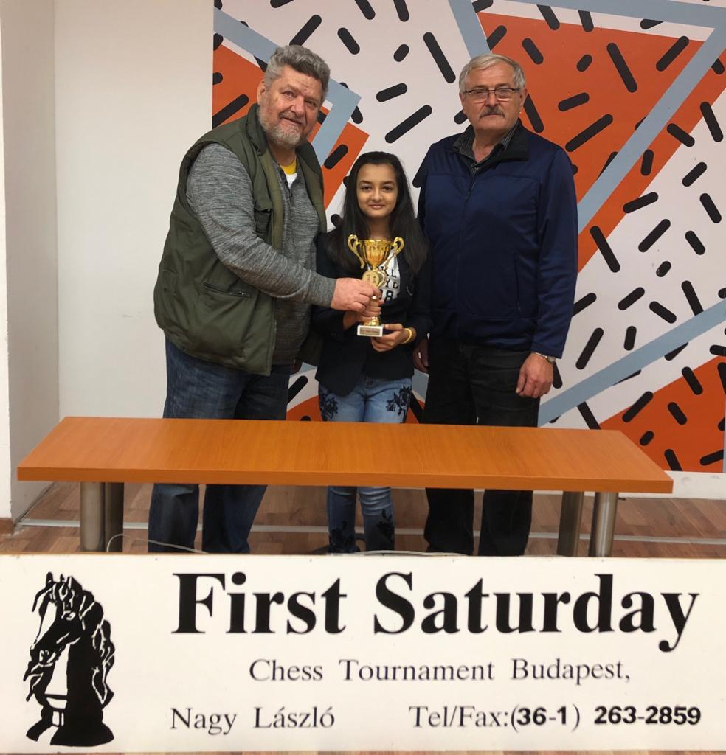

However, the topseed of the tournament GM Ilincic Zlatko from Serbia remains to hold on his title & was unbeaten in the IM tournament!

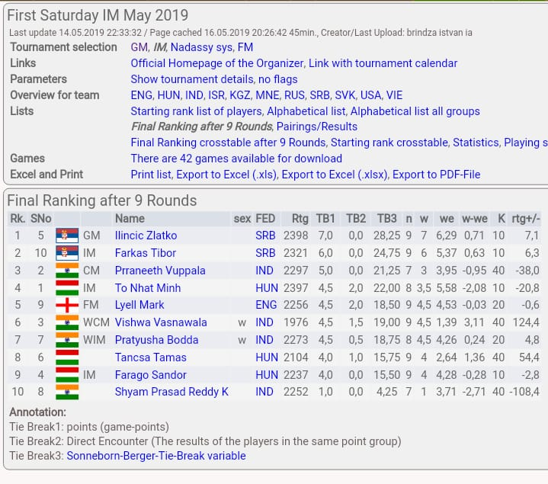

Also let’s have a look at the FM group

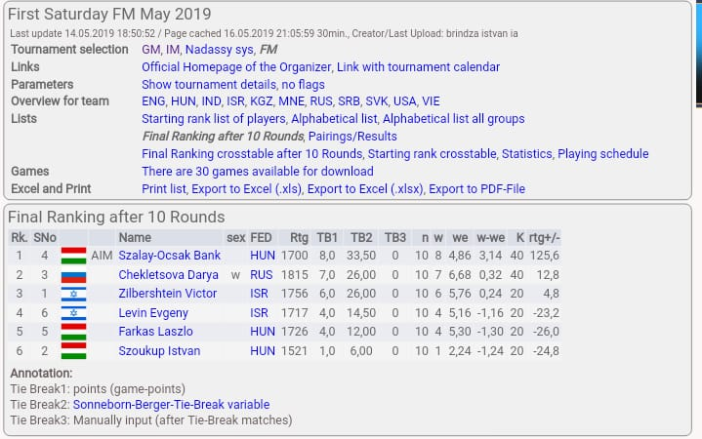

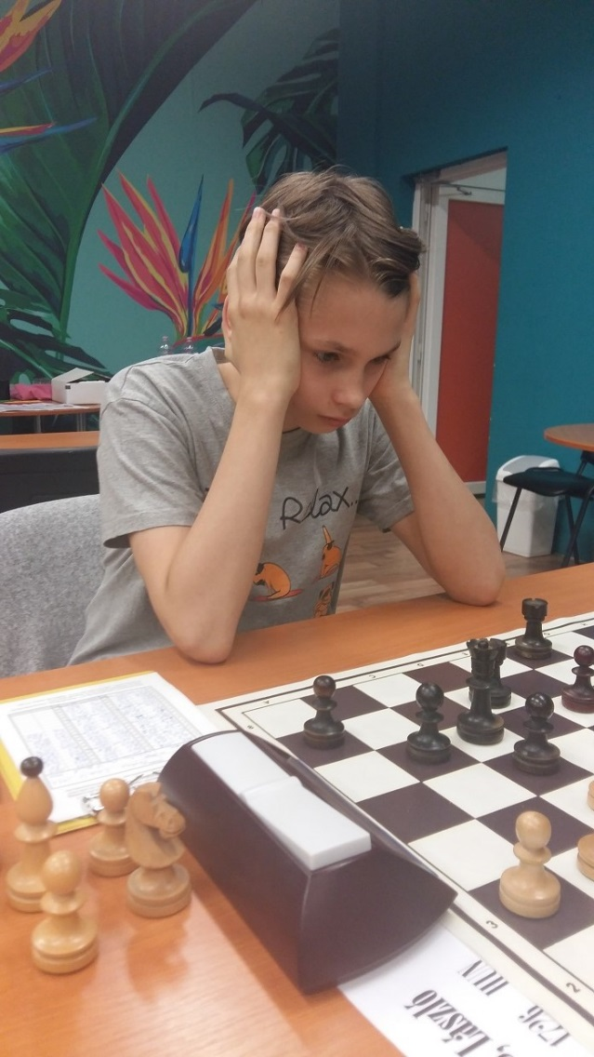

AIM Szalay Ocsak Bank from Hungary scores good enough points to become the champion!

And Finally we’ve got the Nadassy system which is a typical event of First Saturday!

Amongst th B-group players the Indian 15 year girl, Jain Nityata wa the best.

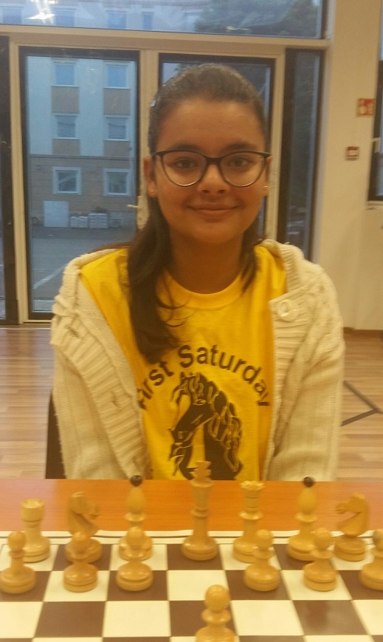

“B Teams Lower Elo” seems to have a much better coordination to beat “A Team Higher Elo”! & Chubakov Sultan (KGZ) was the highest points scorer in his team!

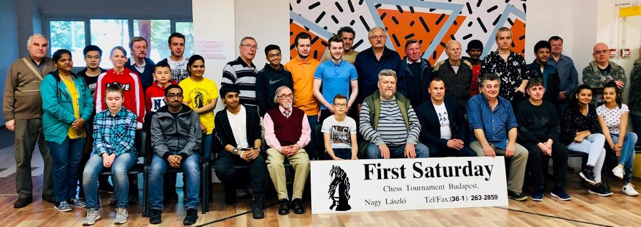

The traditional group photo

The next First Saturday events in Budapest: 1-11 June, 6-16 July, 3-13 August, 7-17 Sept, 5-15 Oct, etc.
www.firstsaturday.hu
Whatsapp: +36-30-230-1914
firstsat@hu.inter.net

